CV Project Report – Oxford102 Flower Dataset
Elective seminar: Artificial intelligence
17.4.2023

Dedeakayoğulları, Selman
Remmler, Mari Susanna
Risyad, Muhammad Emir

Introduction
In this project, we try to classify the OXFORD102 Flowers Dataset using several deep learning models. We explored various models, from a custom model to pretrain models. Our goal was to evaluate the performance of these models and compare their results.

Oxford102 Flower Dataset
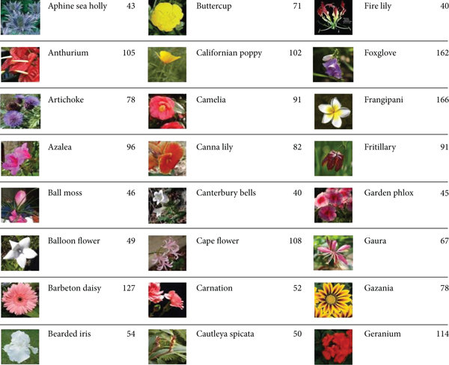
Oxford 102 Flower is an image classification dataset consisting of 102 flower categories, each image is labeled with the name of the flower species it belongs to. The flowers chosen to be flower commonly occurring in the United Kingdom. Each class consists of between 40 and 258 images. The images have large scale, pose and light variations. In addition, there are categories that have large variations within the category and several very similar categories.
Figure 1 OXFORD102 flowers dataset

Custom Model
Making a model from scratch works sometimes for basic problems. But those models are generally not capable to get some good results for more complex problems. Even if you try implement a larger model, it is going to be harder to train. You need more epochs and more computational power.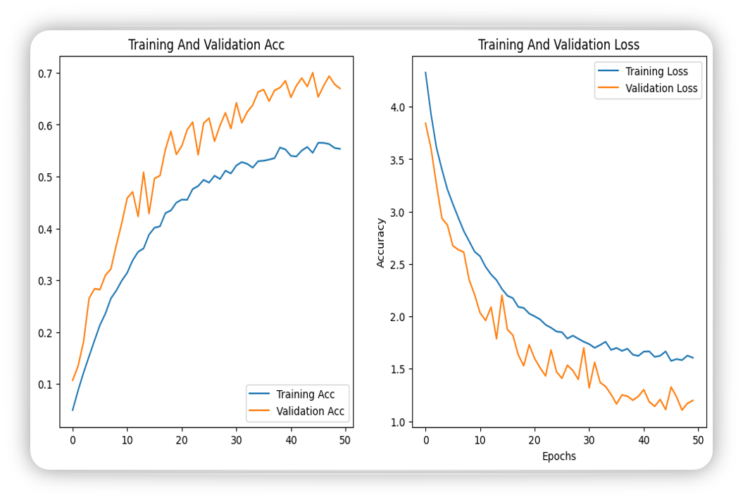
Figure 2 Custom model training history

Our test led to accuracy of approximately 70% after 50 Epochs.

RESTNET50
RestNet50 is a convolutional neural network architecture that is often used for image classification tasks. It consists of 50 layers, 48 convolutional layers, 1 MaxPool layer and 1 average pool layer. The architecture was introduced in the 2015 paper "Deep Residual Learning for Image Recognition" by Kaiming He, Xiangyu Zhang, Shaoqing Ren, and Jian Sun. One of the key innovations of the ResNet architecture is the use of residual blocks, which allow the network to learn more complex features without suffering from the vanishing gradient problem.

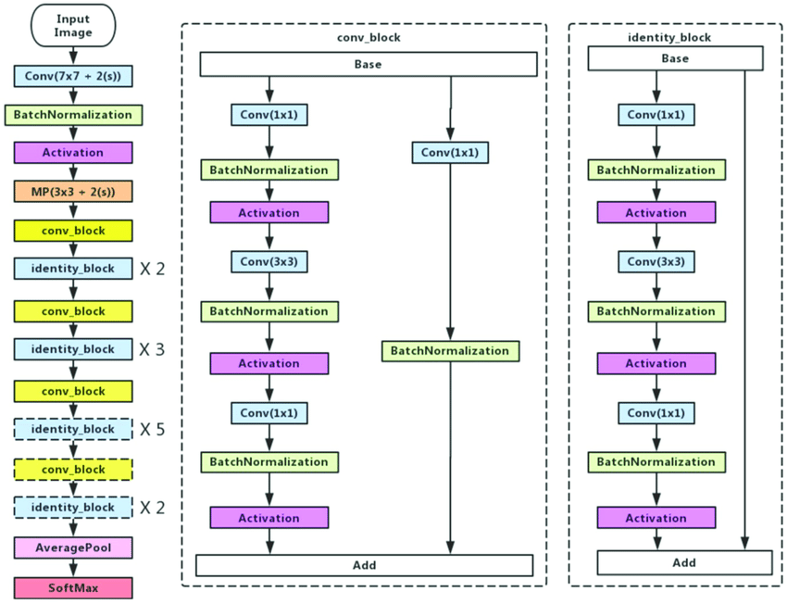
Figure 3 RESTNET50 Architecture
We tried to do fine tuning with the model to fit better with our dataset, because this model can easily become overfitted if not controlled.
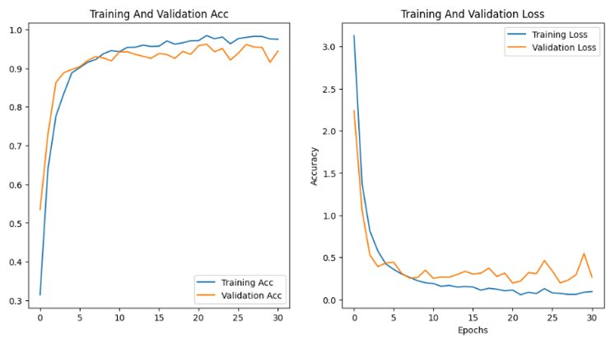
Figure 4 RESTNET50 training history

We manage to get 95% accuracy from this model.

VGG16
VGG16 is a convolutional neural network architecture that was introduced in 2014. It is named "VGG" because it was developed by the Visual Geometry Group at the University of Oxford. VGG16 consists of 16 layers, including 13 convolutional layers and 3 fully connected layers. It is used for image classification and recognition tasks, and has achieved state-of-the-art performance on the ImageNet dataset. The architecture is characterized by its simplicity and uniformity, with all convolutional layers having a 3x3 filter size and all pooling layers having a 2x2 filter size.
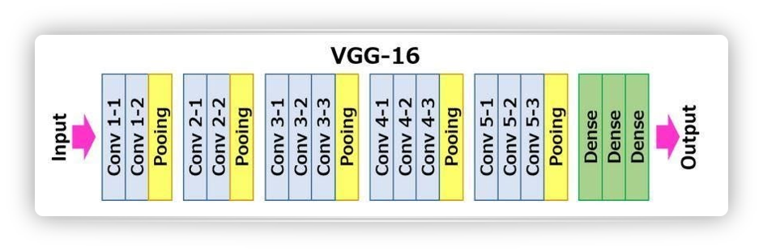
Figure 5 VGG16 architecture

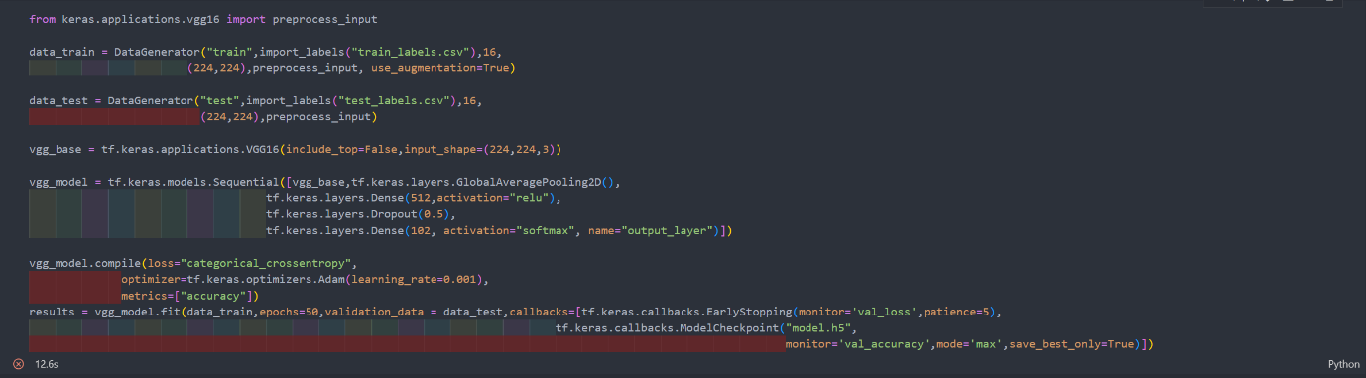
Figure 6 VGG16 code

Unfortunately, we were not able to use VGG16 due Resource Exhaustion Error.

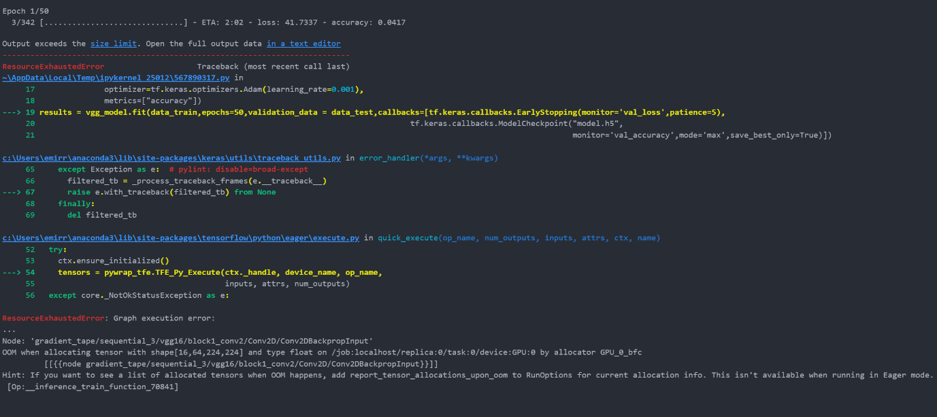
Figure 7 VGG16 error message

MobileNetV2
MobileNetV2 is a convolutional neural network architecture that was introduced in 2018. It is designed for mobile and embedded vision applications, where computational resources are limited. MobileNetV2 is based on the MobileNet architecture, but with significant improvements in terms of accuracy and speed. It uses a technique called "inverted residual blocks", which consist of a depthwise convolution (which applies a single filter per input channel) followed by a pointwise convolution (which applies a linear combination of filters to the outputs of the depthwise convolution). This allows for a significant reduction in computational cost, while still maintaining high accuracy.
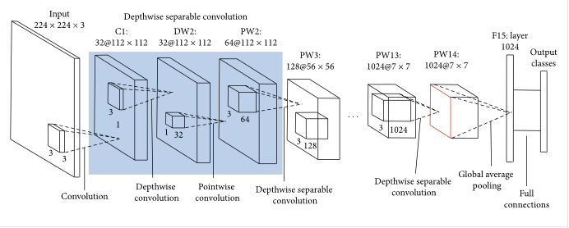
Figure 8 MobileNetV2 architecture

We got the highest accuracy from this model, which is 95.6% accuracy.

What we learned
Selman:
Emir: Everything. Before doing this project, I have no idea about how a machine learning model work. But after trying and failed on some model I got a new knowledge about machine learning models that can be used to identify an object and how to fine tune the models to fit our dataset.
Mari:

